Proposal for Energy Explorer (NASA Data Pathfinder)

Team Members: Rashona Yang, Yash Choksey, Mei Huang, Oluwapamilerin Amuda, Veevek Dave

Team Name: SPAMW

### Summary of Proposed Project

NASA’s earth science database has a large barrier to entry; the data is confusing and hard to locate, and trying to understand it requires a degree in data science. This gets in the way of a lot of meaningful citizen science, and thus the potential for this information is squandered. One question this information could try to answer is: what factors can lend a country's decision to go “green”. Finding out what type of renewable energy is viable for specific regions is a major question involving natural, economic, and political factors. NASA has that natural data to support the question, but it's buried behind data paths and archives. Thus the goal of Energy Explorer is to create an intuitive and user-friendly site to display these resources to the general public. The site will employ a responsive and convenient user interface, utilizing data-visualization to communicate requested data as effectively as possible.

### 

### Functional Requirements

* People: Users must be able to navigate the Energy Explorer data pathfinder with ease on their device(s).
* Process: The pathfinder will include a Landing Page and associated pages for Solar, Wind, Hydro, Geothermal, and Biomass datamaps.
  + Users must be able to read how to navigate the datamaps and what data is available via the Landing Page.
  + Users must be able to select the available datamaps.
  + Users must be able to view and download the datamaps such as graphs, maps, and charts.
  + Users must be able to filter the datamaps by country.
  + Users must be able to search for specific data or information.
* User Interface: The user interface must be similar to current pathfinders and be intuitive to use for the general public.

### 

### Non-functional Requirements

* Software: The site will be the same experience through Chrome and Firefox on multiple devices.
* Data Collection: The site must be able to fetch updated or additional NASA data relevant to their pathfinder.
* Data Storage: The site must be able to access the stored NASA data for their pathfinder.
* User Experience: The site must ensure accessibility, the website should follow the Gestalt principle, and iterative testing should be conducted throughout the development process.
* Performance: The site must be able to handle regular expected traffic (based on previous data pathfinders) to the site.
* Scalability: The site must be able to scale as the amount of data and users increases over time.
* Maintainability: The site must use libraries and packages that are unlikely to be depreciated within the next 5 years.

### 

### Users And Stakeholders

Users:

1. General Public User - Citizen Scientist
   1. General public user (specifically a citizen scientist) is someone who has limited experience using NASA Earth Science data but has an interest in the data interpretation and is collecting data for input into some local, regional, national, global data collection. This user will need extensive support with why the data is collected, how it is used and relationships between data types. More than likely just wants to download a visualization of data.
   2. Expectations: Can download data visualizations; can link different types of data or even overlay data sets.
2. General Public User - Science Interested
   1. General public user is someone who has limited experience using NASA Earth Science data but has an interest in the data interpretation. This user will need extensive support with why the data is collected, how it is used and relationships between data types. More than likely just wants to download a visualization of data.
   2. Expectations: Can download data visualizations; can link different types of data or even overlay data sets.
3. General Public - Information Only
   1. General public user is someone with limited knowledge and experience with NASA Earth Science data but has an interest in familiarizing themselves with a high level understanding of the data.
   2. Expectations: Can download data visualizations; can link different types of data or even overlay data sets.

Stakeholders:

1. National Aeronautics and Space Administration (NASA) - NASA is looking to increase the accessibility of citizen science through this application, therefore it wants to facilitate citizen scientists in obtaining their data.
2. Rensselaer Polytechnic Institute (RPI) - RPI wants to grow the reputation and credibility of its Information Technology & Web Science (ITWS) program and by partnering with NASA there’s an opportunity to increase visibility of their school and program.
3. RPI Students (the team) - the team wants to contribute to a project of real-world value and gain experience of working with stakeholders outside of academia.
4. Professor Callahan - the professor wants to increase the learning opportunities for ITWS students and encourage students to get the most from the class in preparation for the workforce.
5. Citizen Scientists - citizen scientists are interested in NASA’s data and information to expand their field’s knowledge base.
6. Science Interested - public citizens with some scientific knowledge may find the information useful in exploring relationships between the data provided.
7. General Public - public citizens may be interested in gaining a high level understanding of the information and what data may contribute to a country deciding to “go green”.

### 

### Tech Stack

| Frontend | Backend |
| --- | --- |
| HTML & CSS   * Bootstrap * Tailwind.css   Javascript   * Angular | Node JS  MongoDB  Express.JS  DS.js |

### 

### Timeline

| January 29 | February 12 | February 26 | March 12 |
| --- | --- | --- | --- |
| Start on the HTML by creating the pages and some of the CSS | Continue to style the html pages and CSS and have that finished by end of the day | Work on javascript features of the website Midterm Presentation run throughs | Comb through the features of NASA’s dataset and find out how to use it |

| March 19 | March 26 | April 9 | April 16 | April 21 |
| --- | --- | --- | --- | --- |
| Formula structure of Mongo Database as well as work on the API | Start Visualizing the Data | Finalize Site Pages, Prep for Project Preview Day | Final Bug Fixing. Final Presentation Run Throughs | Final Presentations and project due |

### 

### 

### Site Map

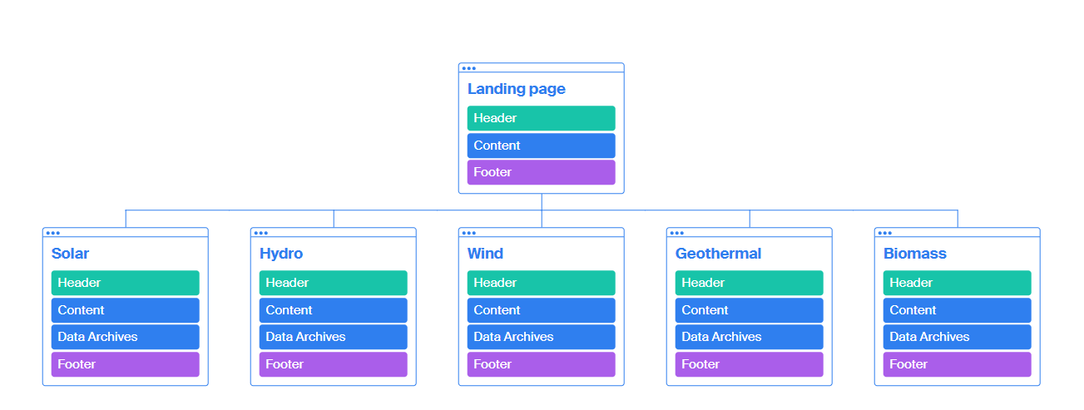

An overview of our proposed site.

### Wireframes

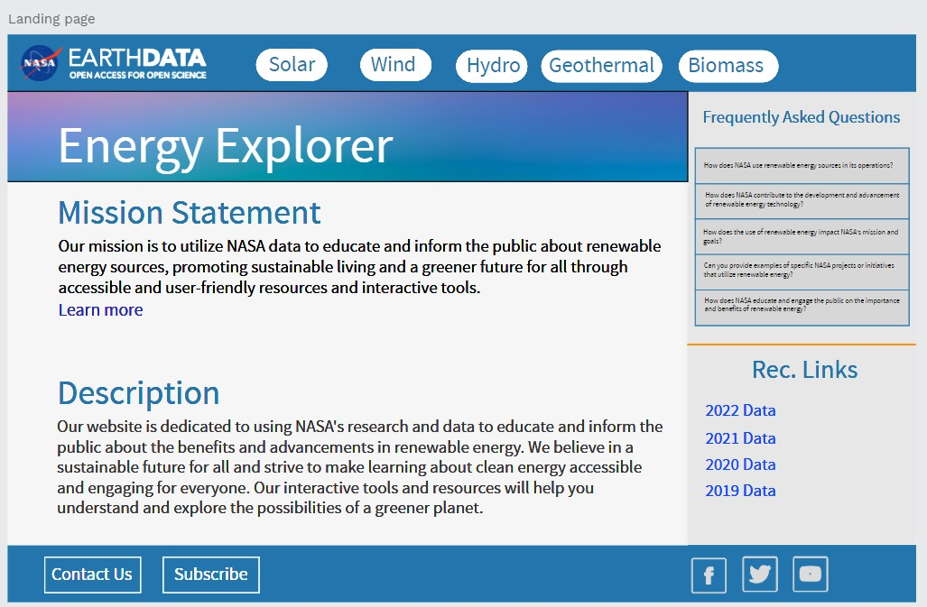

Landing page of the Website. This is the first page users see when they log into our website.

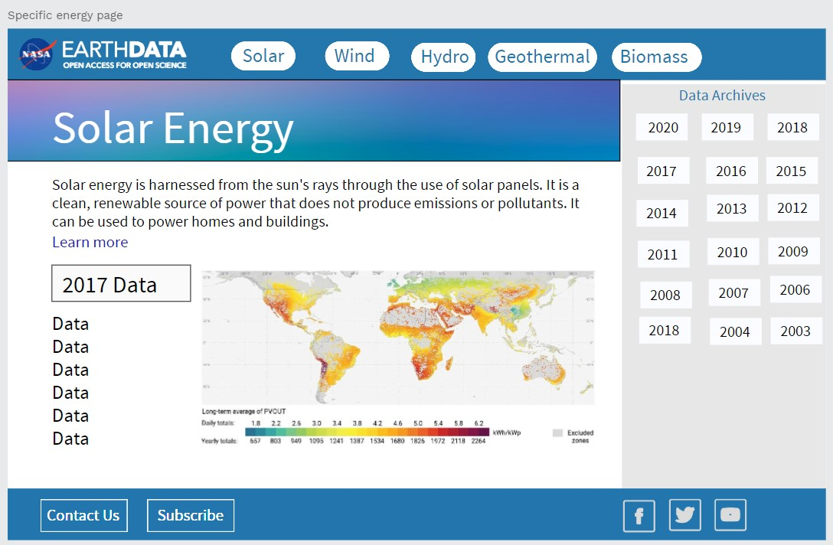

Proposed page focusing on a specific data path.